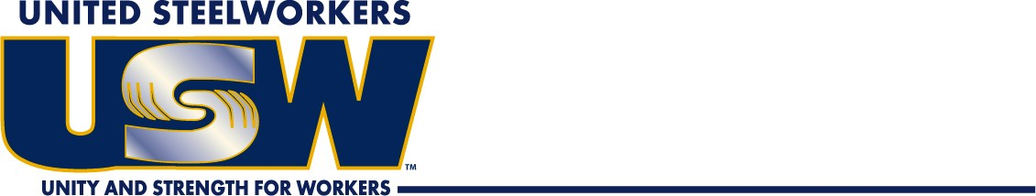

**District 12**

From Gaylon Z Prescott

MEMO

# Legislative Advocacy Training – this is for each local to identify and send a few members to be designated point people for regular engagement with the legislature on policy issues related to refinery workers. We need locals to send a count of how many people they’ll be bringing.

April 27th, 1:00 p.m. -5:30 p.m.

April 28th, 8:30 a.m. - close (no later than 2:00 p.m.)

Location: Hilton Garden Inn - Library

601 James Way

Pismo Beach, CA 93449

If you would like to attend, please contact us, secure the time off from your immediate supervisor, and if you any assistance with that contact us immediately. **(562) 630-6232**

See you in Pismo.

**United Steel, Paper and Forestry, Rubber, Manufacturing, Energy, Allied Industrial and Service Workers International Union**

8131 Rosecrans Ave Paramount CA 90723 (562) 630-6232